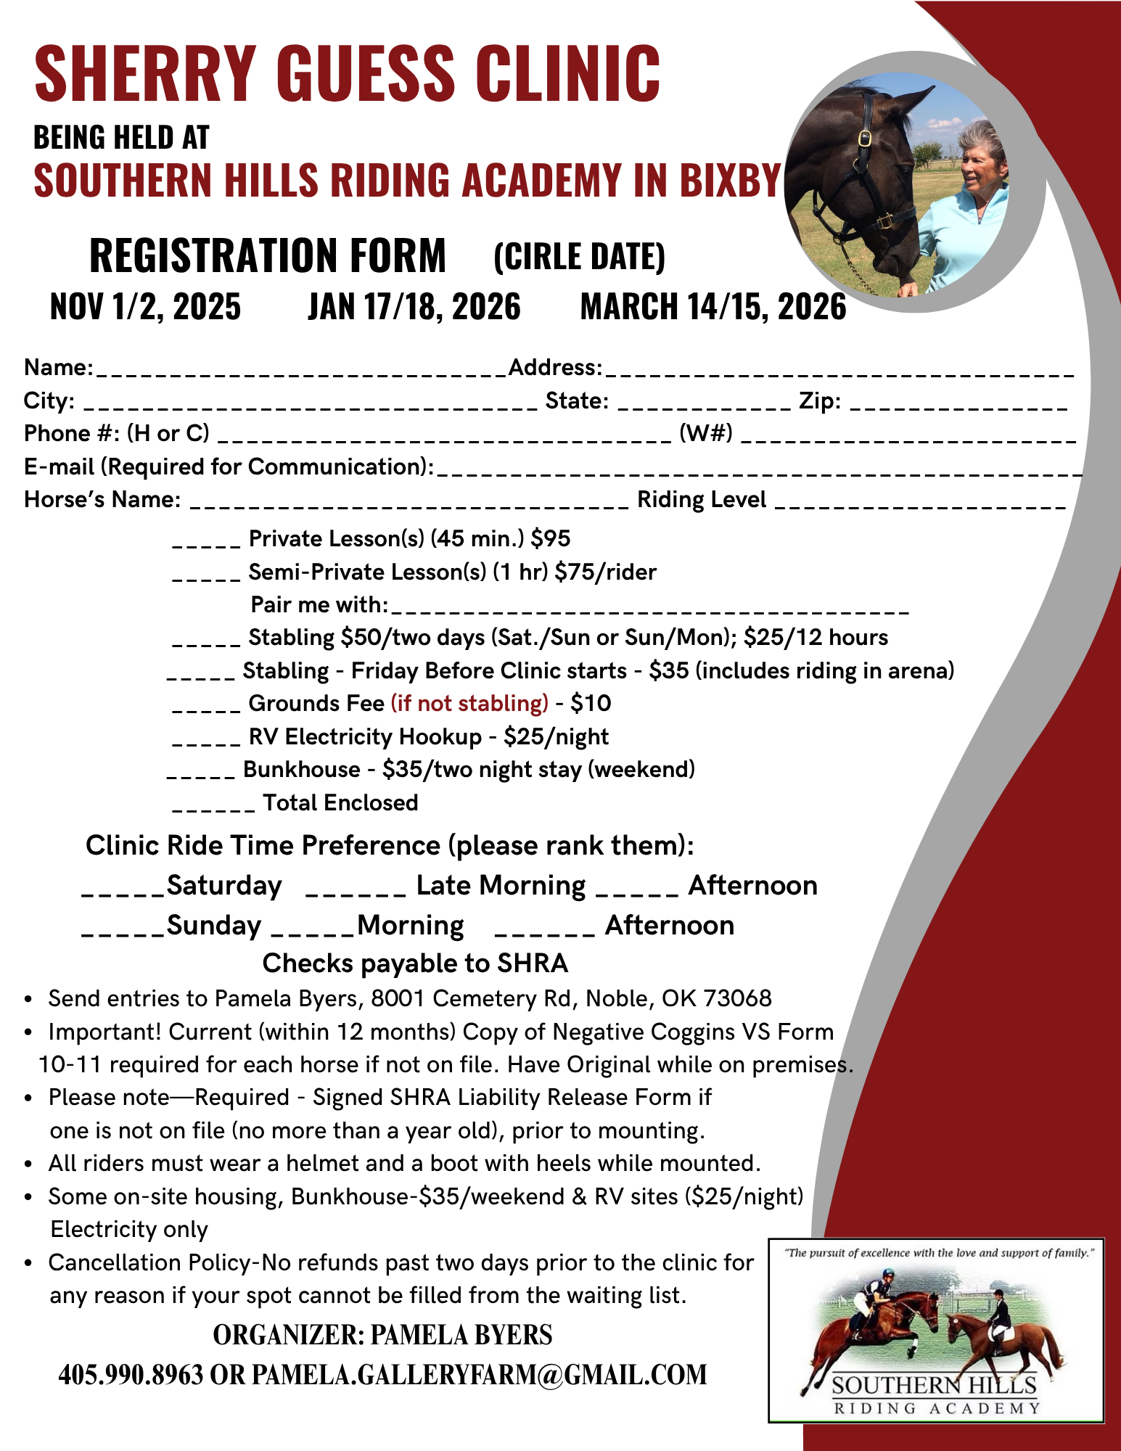
SHERRY GUESS CLINIC
BEING HELD AT
SOUTHERN HILLS RIDING ACADEMY IN BIXBY
REGISTRATION FORM
(CIRLE DATE)
NOV 1/2, 2025
JAN 17/18, 2026
MARCH 14/15, 2026
Name:
_Address:
City:
State:
Zip:
Phone #: (H or C)
(W#)
E-mail (Required for Communication):.
Horse's Name:
Riding Level
Private Lesson(s) (45 min.) $95
Semi-Private Lesson(s) (1 hr) $75/rider
Pair me with:
Stabling $50/two days (Sat./Sun or Sun/Mon); $25/12 hours Stabling - Friday Before Clinic starts - $35 (includes riding in arena) Grounds Fee (if not stabling) - $10
RV Electricity Hookup - $25/night
Bunkhouse - $35/two night stay (weekend)
Total Enclosed
Clinic Ride Time Preference (please rank them):
Saturday
Late Morning
Afternoon
_Sunday _____ Morning
Afternoon
Checks payable to SHRA
• Send entries to Pamela Byers, 8001 Cemetery Rd, Noble, OK 73068 Important! Current (within 12 months) Copy of Negative Coggins VS Form
•
•
10-11 required for each horse if not on file. Have Original while on premises. Please note Required - Signed SHRA Liability Release Form if
one is not on file (no more than a year old), prior to mounting.
• All riders must wear a helmet and a boot with heels while mounted.
• Some on-site housing, Bunkhouse-$35/weekend & RV sites ($25/night) Electricity only
• Cancellation Policy-No refunds past two days prior to the clinic for any reason if your spot cannot be filled from the waiting list.
ORGANIZER: PAMELA BYERS
405.990.8963 OR PAMELA.GALLERYFARM@GMAIL.COM
"The pursuit of excellence with the love and support of family."
SOUTHERN HILLS
RIDING ACADEMY

