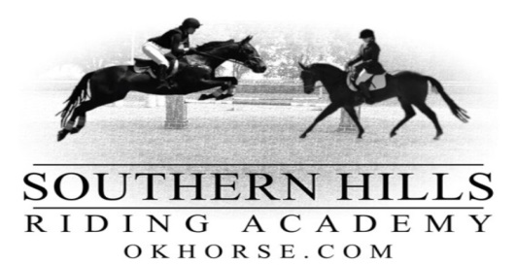
RELEASE AND HOLD HARMLESS AGREEMENT
The undersigned assumes the unavoidable risks inherent in all horse-related activities, including but not limited to bodily injury and physical harm to horse, rider, and spectator.
In consideration, therefore, for the privilege of riding and/or working around horses at SOUTHERN HILLS RIDING ACADEMY, INC. 14644 S. Lewis Ave. Bixby, OK74008, OR AT ANY OTHER LOCATION, the Undersigned does hereby agree to hold harmless and indemnify SOUTHERN HILLS RIDING ACADEMY, INC.,KIM M. DYER, JIMMY DOUGLAS DYER, OR ANYONE ASSOCIATED WITH THEM, and further releases them from any liability or responsibility for accident, damage, injury, or illness, or injury or illness to my horse, to accompanying the Undersigned on the premises.
I have read and do understand the posted rules of this stable and will abide by them.

Signature

Print Name, Address and Phone Number

Address of Parent or Guardian
Horse Owners Name:_____________________________________
Name of Horse:_________________________________________
Home Phone Number:___________________________________
Driver’s License Number:_________________________________
Insurance Company:____________________________________
Physician’s Name & Phone Number:_____________________________

WARNING: UNDER OKLAHOMA LAW, A LIVESTOCK PROFESSIONAL OR LIVESTOCK ACTIVIITIES SPONSOR IS NOT LIABLE FOR AN INJURY TO A PARTICIPANT IN LIVESTOCK ACTIVITIES RESULTING FROM THE INHERENT RISKS OF LIVESTOCK ACTIVITIES, PURSUANT TO THE OKLAHOMA LIVESTOCK LIABILITY LIMITATION ACT.

